|  |
| --- |
| NAME : SHASHWAT SHAH  SAP ID : 60004220126  DIV: B3  Experiment 1 : Explore the internal commands of linux and Write shell scripts |

AIM

**:-**

Explore the internal commands of linux and

Write shell scripts

to do the following:

**1.**

**Display top 10 processes in descending order**

**2.**

**Display processes with highest memory usage.**

**3.**

**Display current logged in user and no. of users**

4.

**Display current shell, home directory, operating system type, current working directory**

.

5.

**Display OS version, release number**

.

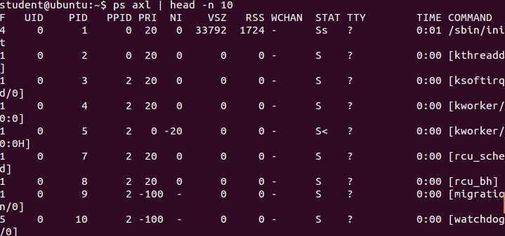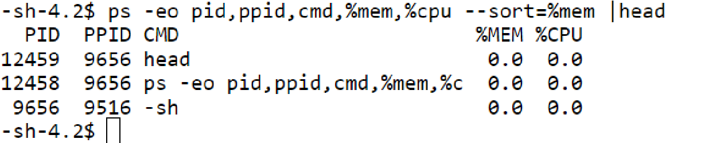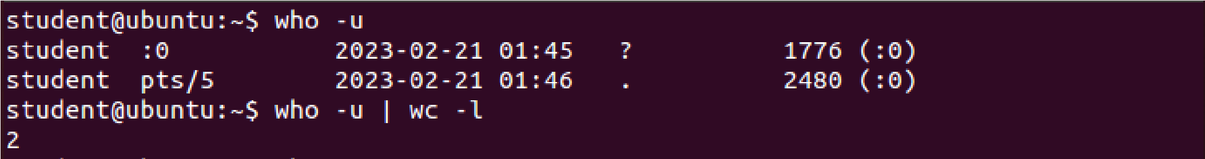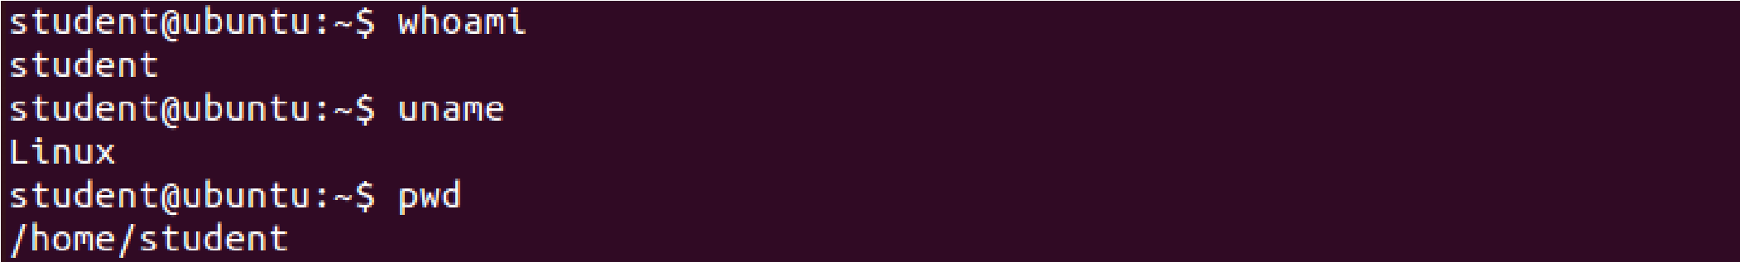

**6.**

**Illustrate the use of sort, grep, awk, e**

tc

Conclusion :

Hence all the internal commands of Linux were understood and

Performed.

